Diabetes Prediction Model Project (Streamlit)
Project Overview
The Diabetes Prediction Model is a Python-based machine learning project designed to predict the likelihood of diabetes in individuals. The project uses health-related input features such as glucose level, blood pressure, BMI (Body Mass Index), age, insulin level, and more. The model analyzes these inputs to generate a probability score indicating the risk of diabetes.
The entire project is deployed as a web application using Streamlit, which allows users to interact with the model in real time without needing programming knowledge.

Key Features
- Interactive Web Interface: Users can enter their health data through easy-to-use input fields.
- Real-Time Prediction: Provides instant feedback about the risk of diabetes.
- Probability Score: Shows the likelihood of diabetes in percentage form.
- Silent and Secure: The app processes user input without sending data anywhere externally.
- Visualization: Optional charts and graphs to visualize the input or prediction results.

Libraries Used
- pandas: For data loading, cleaning, and manipulation.
- numpy: For numerical operations on data arrays.
- scikit-learn: For machine learning, including model training, testing, and prediction. Common models used: Logistic Regression, Random Forest, SVM.
- pickle: For saving and loading the trained machine learning model.
- streamlit: For building the interactive web application interface.
- matplotlib / seaborn (optional): For creating charts and data visualizations.

Workflow
- Data Collection & Preprocessing
  - Load dataset containing health parameters and diabetes labels.
  - Handle missing values and perform data cleaning.
  - Scale or normalize data if needed (important for models like SVM).
- Model Training
  - Choose a machine learning algorithm (e.g., Logistic Regression, Random Forest).
  - Split data into training and testing sets.
  - Train the model on the training data.
  - Evaluate accuracy using testing data.
- Model Saving
  - Save the trained model using pickle so it can be loaded later in the web app.
- Streamlit App Development
  - Create input fields for each health parameter.
  - Load the trained model inside the Streamlit app.
  - Accept user input and preprocess it as needed.
  - Generate prediction using the model.
  - Display results along with probability and optionally visual charts.
- Deployment & Usage
  - Run the app using:
  - streamlit run app.py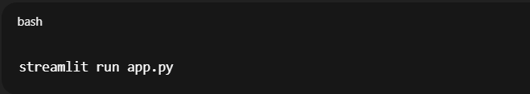
  - Users enter their health details and click a button to get predictions instantly.

Advantages
- Provides a simple, user-friendly way to predict diabetes risk.
- Helps users take preventive actions early.
- Combines data science with web deployment for practical usage.
- Fully customizable: You can swap models, add features, or enhance visuals.

Installation Instructions
- Install Python 3.x on your system.
- Install required libraries: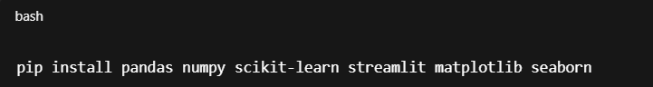
- pip install pandas numpy scikit-learn streamlit matplotlib seaborn
- Place your trained model file (e.g., diabetes_model.pkl) in the project folder.
- Run the Streamlit app:
